***Virginia Junior Classical League***

*presents this*

Certificate of Excellence

*to*

Caroline Armstrong

*of*

Deep Run High School

*for*

*6th Place in Derivatives*

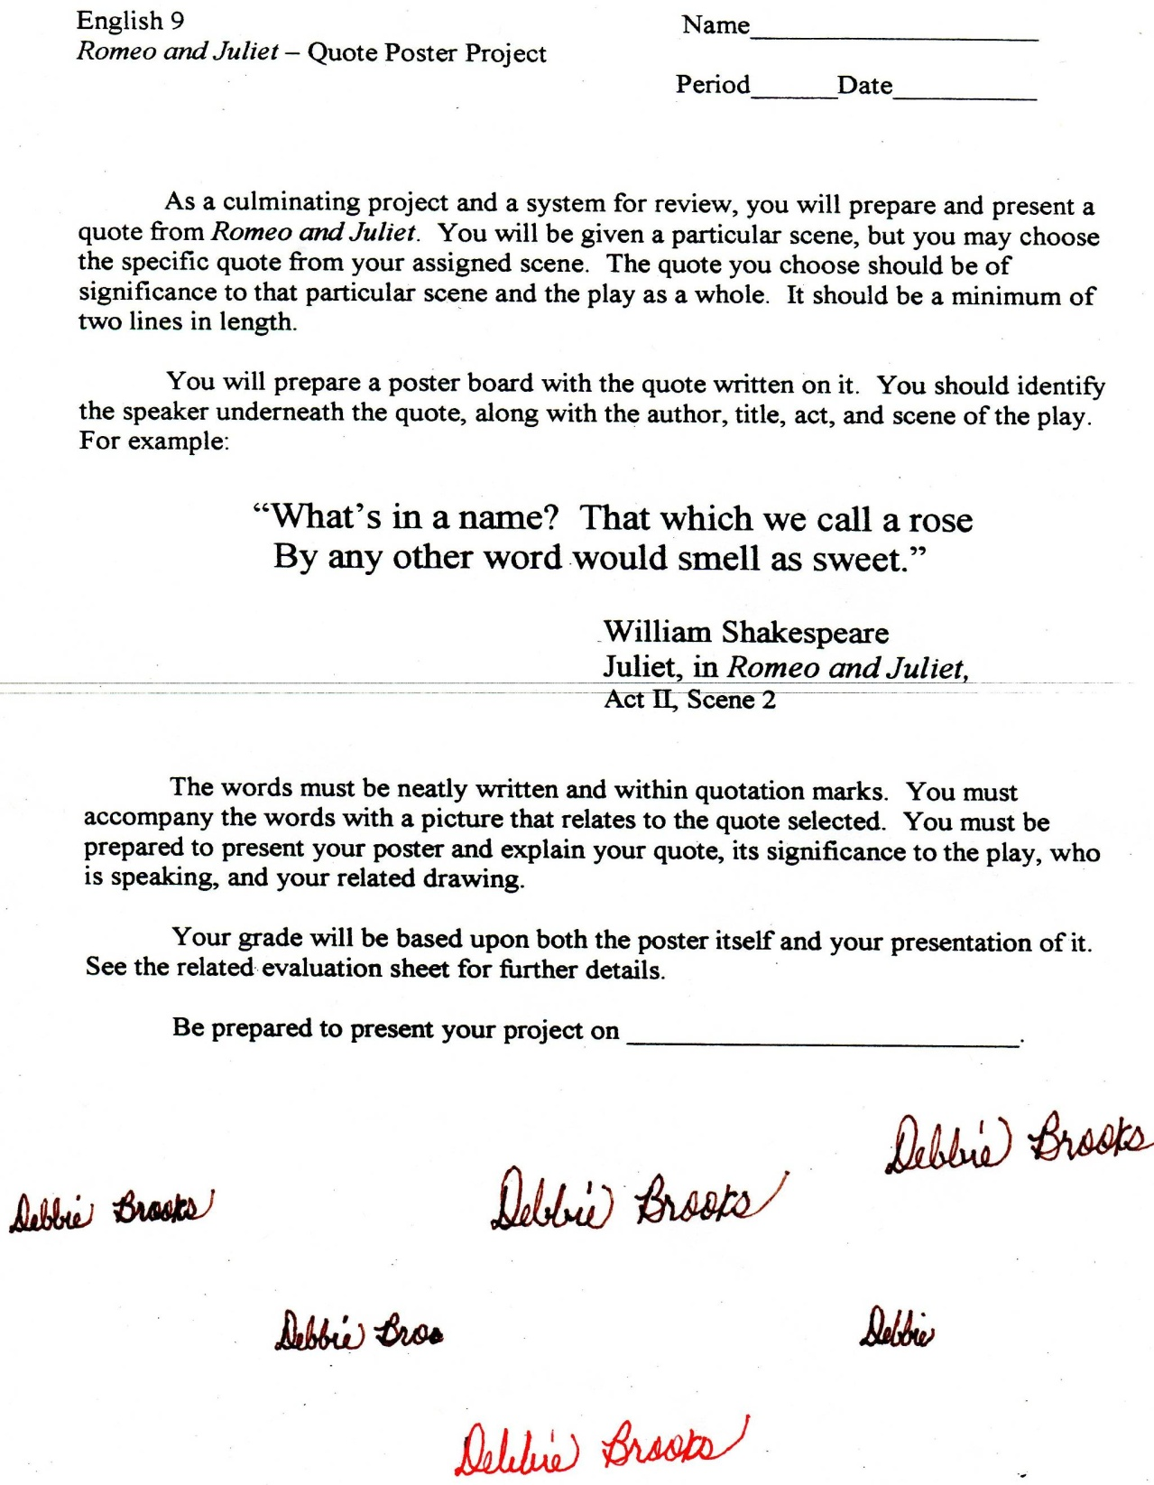

Microsoft Office Signature Line...

*a.d. viii Kal. Dec. MMDCCLXVII A.U.C. 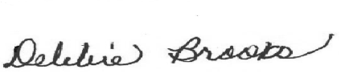*

***Virginia Junior Classical League***

*presents this*

Certificate of Excellence

*to*

Caroline Armstrong

*of*

Deep Run High School

*for*

*6th Place in Reading Comprehension*

**

Microsoft Office Signature Line...

*a.d. viii Kal. Dec. MMDCCLXVII A.U.C. *

***Virginia Junior Classical League***

*presents this*

Certificate of Excellence

*to*

Francis Sanchez-Navarrete

*of*

Deep Run High School

*for*

*7th Place in Derivatives*

**

Microsoft Office Signature Line...

*a.d. viii Kal. Dec. MMDCCLXVII A.U.C. *

***Virginia Junior Classical League***

*presents this*

Certificate of Excellence

*to*

Caroline Armstrong

*of*

Deep Run High School

*for*

*7th Place in English Oratory*

**

Microsoft Office Signature Line...

*a.d. viii Kal. Dec. MMDCCLXVII A.U.C. *

***Virginia Junior Classical League***

*presents this*

Certificate of Excellence

*to*

Francis Sanchez-Navarrete

*of*

Deep Run High School

*for*

*7th Place in Vocabulary*

**

Microsoft Office Signature Line...

*a.d. viii Kal. Dec. MMDCCLXVII A.U.C. *

***Virginia Junior Classical League***

*presents this*

Certificate of Excellence

*to*

Pate Richardson

*of*

Deep Run High School

*for*

*9th Place in Reading Comprehension*

**

Microsoft Office Signature Line...

*a.d. viii Kal. Dec. MMDCCLXVII A.U.C. *

***Virginia Junior Classical League***

*presents this*

Certificate of Excellence

*to*

Caroline Armstrong

*of*

Deep Run High School

*for*

*9th Place in Vocabulary*

**

Microsoft Office Signature Line...

*a.d. viii Kal. Dec. MMDCCLXVII A.U.C. *